Oregon State University

06.2008
ECE 418 Suprem Project

Wen Tong
Jon Guerber

Contents
I. Introduction 4
II. Transistor Simulations 5
The final plot of the structure of the simulated MOS device with a 25 micron gate length: 5
The doping of the device: 6
The mesh used to simulate the device: 7
The resulting Ids vs. Vgs curves after atlas simulation: 7
The script used for simulating the transistor in SUPREM: 9
III. Diode Simulations 12
The simulated diode structure for the parameters of the diode we have created: 12
The diode showing device doping characteristics: 13
The Anode current vs. the Anode Voltage for the simulated diode: 14
The SUPREM script used to simulate the diode: 15
IV. Deviations From the Ideal 18
Appendix A: Matlab Transistor Plotting Script 19
Appendix B: Matlab Diode Plotting Script 23
Appendix C: Suprem Data Plots 24

Table of figures
Figure 1: The MOSFET Structure (dimensions in microns) 4
Figure 2: MOSFET Doping Profile 5
Figure 3: Mesh for Simulating MOSFET Device 6
Figure 4: Ids vs. Vgs Plot for 25 micron MOSFET 7
Figure 5: Diode Simulated Structure 11
Figure 6: Diode Doping Characteristics 12
Figure 7: Diode IV Curve 13
Figure 8: The SUPREM plot of the MOSFET Id vs. VGS 23
Figure 9: Diode Ia vs. Va SUPREM Plot 24

I. Introduction
In the course of developing new technologies, it’s vital to carefully simulate the final product before fabrication. In our case, we were building a 25 micron gate length PMOS transistor and the results from the simulation are described in this report. The simulation is a of a cross section of the transistor, 600 microns in length, and 1 micron in length, taken so as to include all important features. Data from the simulation was taken from the ideal process flow created for the ECE 418 lab session.
While most of the simulation was completed as described in the process flow, there was one minor change, which was that in the simulation, our diffusion regions were created by depositing a phosphorus doped oxide rather than the simple spin on dopant. However, this should not lead to drastic changes in the results of the simulation.
This report is organized into 3 main sections. The first addresses the transistor simulations, the second looks at the diode simulations, and the this talks about some of the deviations from what would be ideally anticipated. Finally at the end, we have included some of the code used from the plotting functions for the MOSFET and diode.
II. Transistor Simulations

The final plot of the structure of the simulated MOS device with a 25 micron gate length:
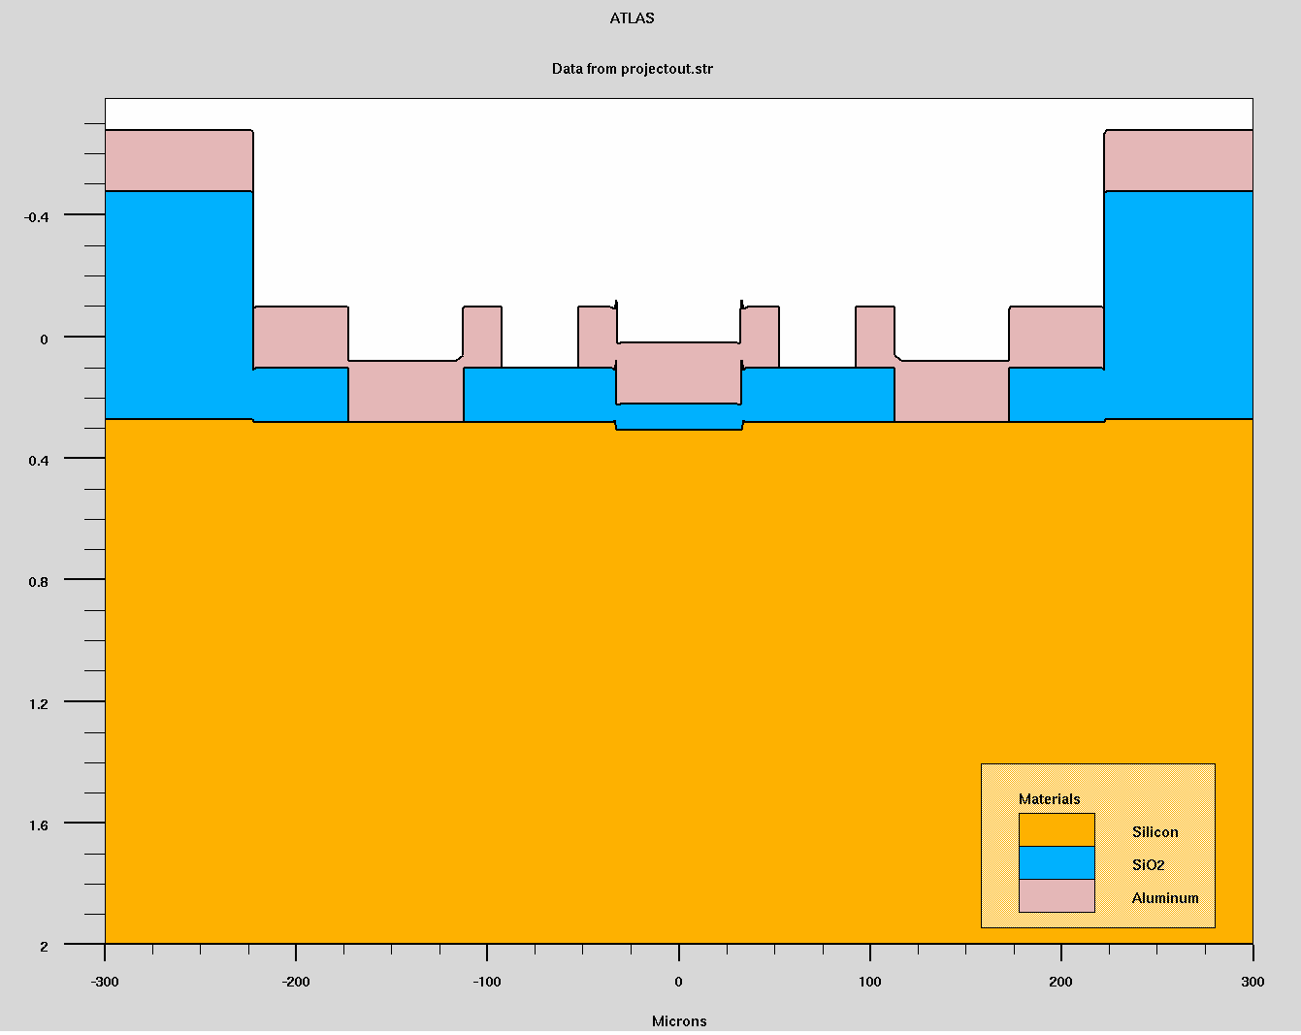
Figure 1: The MOSFET Structure (dimensions in microns)

This plot only shows the actual silicon, oxide, and aluminum structures. The gate contact is the middle aluminum region while the source and drain are located on either side of the device. Below the gate, one can see a thin, precisely grown gate oxide layer.

The doping of the device:

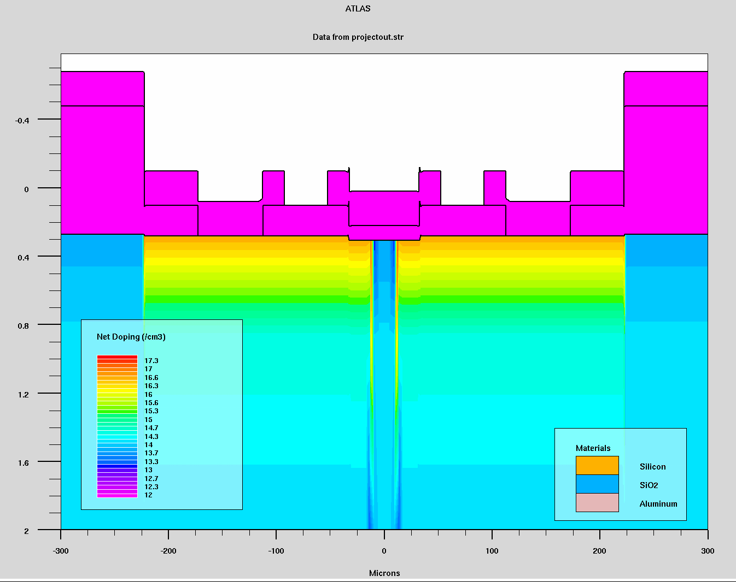
Figure 2: MOSFET Doping Profile

Here, one can se that the doping profile is directly below the source and drain contacts, but is not under the gate contact. This allows for a small depletion region, ;which become an inversion region with the application os a gate bias voltage.

The mesh used to simulate the device:

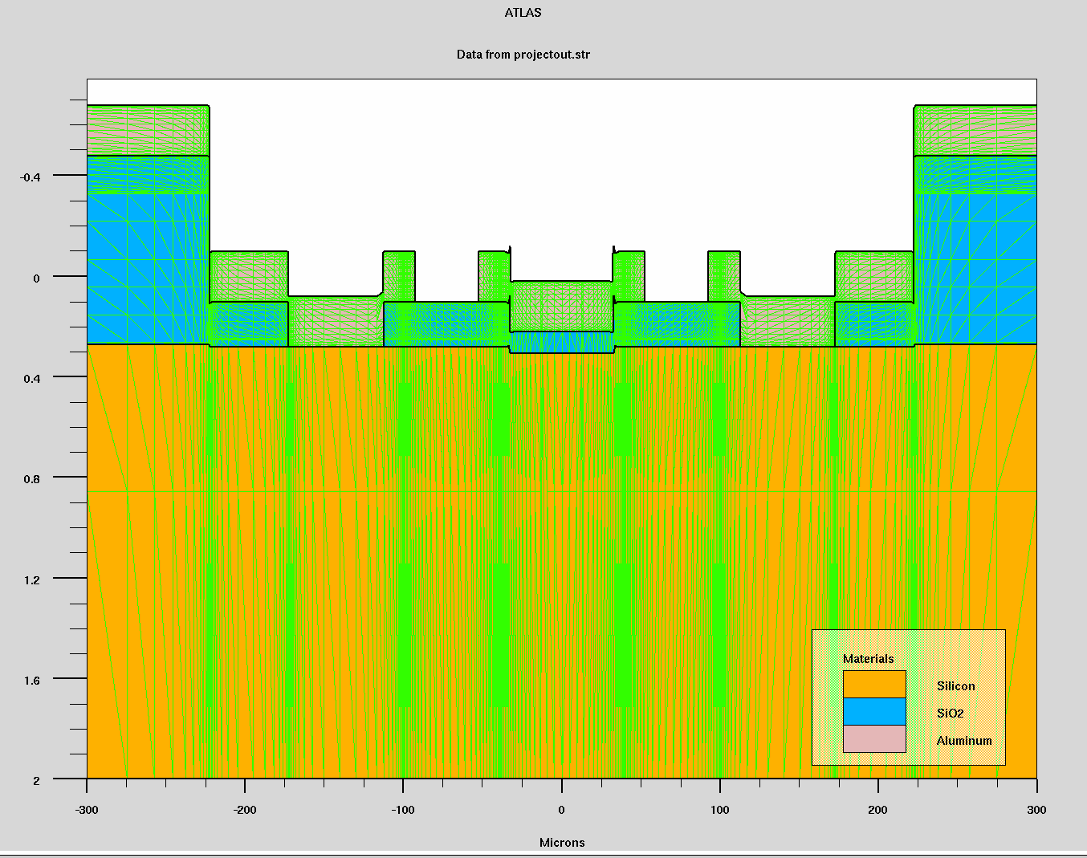
Figure 3: Mesh for Simulating MOSFET Device

This plot illustrates that the mesh has been carefully tuned to create very exact values where there are horizontal transitions in the aluminum or oxide. This allows for exact measurements in those places, but more general measurements, where the precision in not needed.

The resulting Ids vs. Vgs curves after atlas simulation:

Figure 4: Ids vs. Vgs Plot for 25 micron MOSFET

These are what would be expected, and show flat saturation curves. This means there is infinite output impedance of the simulated transistor. Also important to note is the clearly defined triode and saturation break on the graph.

The script used for simulating the transistor in SUPREM:

#########################################################
#
# The Mosfet Builder and Simulator
#
# Created by Jon Guerber
#
# 5-24-2008
#
##########################################################

go athena

############### Intitlizing the Mesh #################

### Horizntal Spacing
line x loc=0.0 spac=5
line x loc=40 spac=.5
line x loc=70 spac=5
line x loc=100 spac=.5
line x loc=140 spac=10
line x loc=172 spac=.5
line x loc=195 spac=10
line x loc=222 spac=.5
line x loc=300 spac=25

### Vertical Spacing
line y loc=0.0 spac=1
line y loc=2 spac=5

############# Setting Inital Silicon Parameters ##############

init silicon c.boron=1.0e14 orientation=111

################# Diffusion of N-Well ##################

### Barrier Oxide Growth
diffus time=40 temp=1100 weto2

### Diffusion window etch
etch oxide start x=12.5 y=-1
etch cont x=12.5 y=1
etch cont x=222.5 y=1
etch done x=222.5 y=-1

### P-Glass Deposition
deposit oxide thick=0.15 c.phosphor=1.0e18

### Drive-in Step
diffus time=30 temp=1100 pres=1 nitro

################### Gate Formation ##################

### Gate Etch
etch oxide start x=0 y=-1
etch cont x=0 y=1
etch cont x=32.5 y=1
etch done x=32.5 y=-1

### Thin Gate Oxide Diffusion
diffus time=20 temp=1100 dryo2 hcl.pc=1

############ Aluminum Contact Creation #############

### Aluminum Contact Window Etch
etch oxide start x=112.5 y=-1
etch cont x=112.5 y=1
etch cont x=172.5 y=1
etch done x=172.5 y=-1

### Aluminum Depostion
deposit aluminum thick=0.2

### Seperation Etching
etch aluminum start x=52.5 y=-1
etch cont x=52.5 y=.3
etch cont x=92.5 y=.3
etch done x=92.5 y=-1

structure mirror left

############# Define the Electrodes ##################

electrode name=gate x=0
electrode name=source x=-150
electrode name=drain x=150
electrode name=substrate backside

structure outfile=Jon.str

################ Initialize the IV Curve ###############

go atlas

### Load in the Meshed Structure
mesh inf=Jon.str
models conmob
method newton
solve init

############## Creating the Log File ##################

log outf=project.log

### Sweep the drain and voltage and save to log file
solve vgate=0 vdrain=0 vstep=.5 vfinal=20 name=drain
solve vgate=1 vdrain=0 vstep=.5 vfinal=20 name=drain
solve vgate=2 vdrain=0 vstep=.5 vfinal=20 name=drain
solve vgate=3 vdrain=0 vstep=.5 vfinal=20 name=drain
solve vgate=4 vdrain=0 vstep=.5 vfinal=20 name=drain
solve vgate=5 vdrain=0 vstep=.5 vfinal=20 name=drain

### Save Everything
save outf=projectout.str

### Plot it all
tonyplot project.log
tonyplot projectout.str

Quit

III. Diode Simulations

The simulated diode structure for the parameters of the diode we have created:

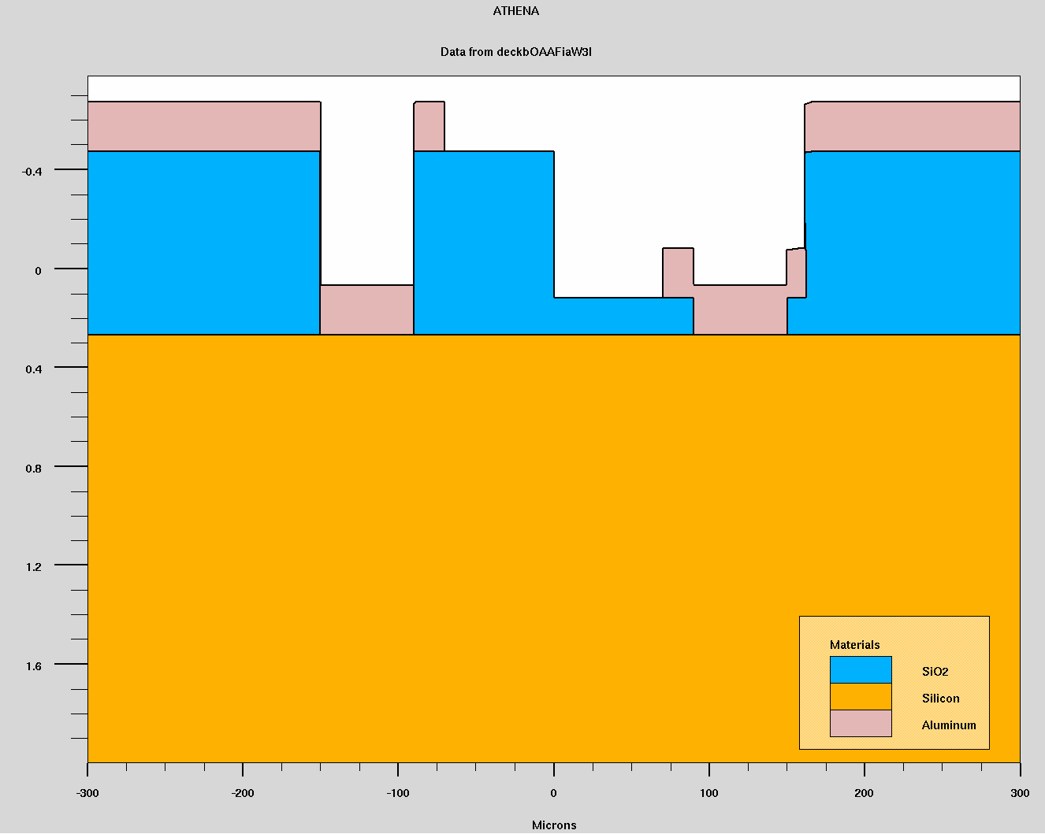
Figure 5: Diode Simulated Structure

From this picture, it is clear that the structure is much like that of the MOS transistor, only with one nwell.

The diode showing device doping characteristics:

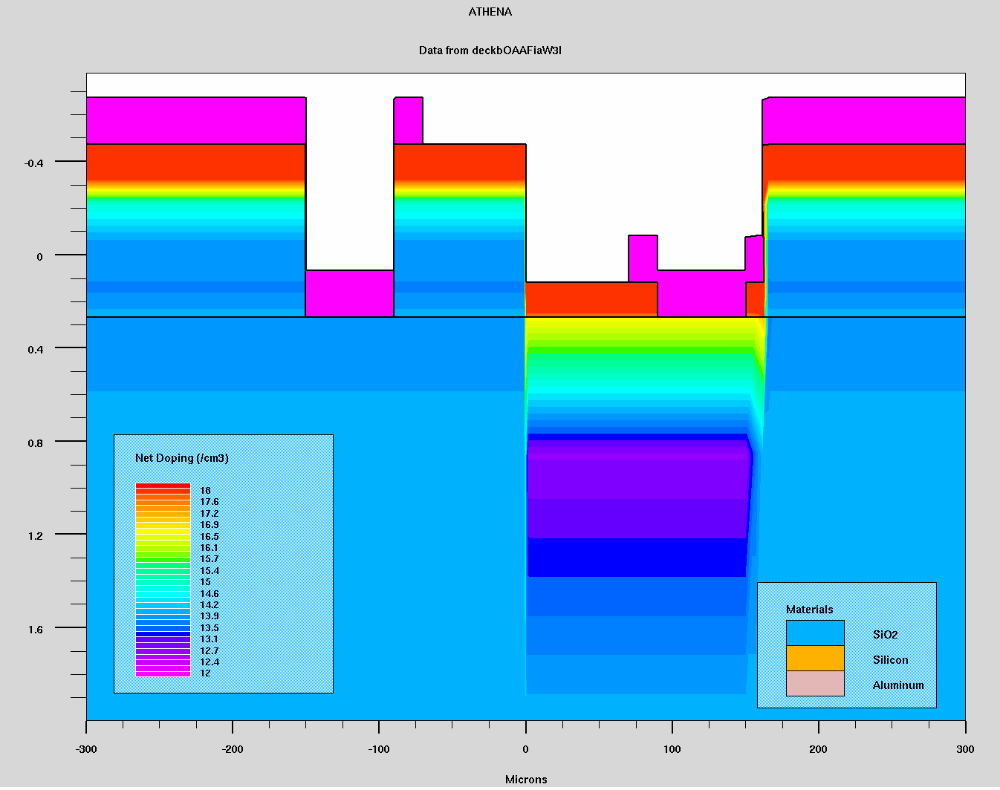
Figure 6: Diode Doping Characteristics

As the diffusion step was the same as in the MOSFET, it would seem only logical that this diffusion profile looks much like that for the transistor.

The Anode current vs. the Anode Voltage for the simulated diode:

Figure 7: Diode IV Curve

This looks much like what would be expected for a diode. When the device is reverse biased, the current though the device is nearly zero. When forward biased, there is an exponential growth in the current for a given voltage. At some point, the curve flattens, which is most likely due to the series resistance of the PN junction.

The SUPREM script used to simulate the diode:

#########################################################
#
# The Diode Builder and Simulator
#
# Created by Jon Guerber
#
# 6-1-2008
#
##########################################################

go athena

############### Intitlizing the Mesh #################

### Horizntal Spacing
line x loc=-300 spac=5
line x loc=40 spac=.5
line x loc=70 spac=5
line x loc=100 spac=.5
line x loc=140 spac=10
line x loc=172 spac=.5
line x loc=195 spac=10
line x loc=222 spac=.5
line x loc=300 spac=25

### Vertical Spacing
line y loc=0.0 spac=1
line y loc=2 spac=5

############# Setting Inital Silicon Parameters ##############

init silicon c.boron=1.0e14 orientation=111

################# Diffusion of N-Well ##################

### Barrier Oxide Growth
diffus time=40 temp=1100 weto2

### Diffusion window etch
etch oxide start x=0 y=-1
etch cont x=0 y=1
etch cont x=165 y=1
etch done x=160 y=-1

### P-Glass Deposition
deposit oxide thick=0.15 c.phosphor=1.0e18

### Drive-in Step
diffus time=30 temp=1100 pres=1 nitro

############ Aluminum Contact Creation #############

### Aluminum Contact Window Etch
etch oxide start x=90 y=-1
etch cont x=90 y=1
etch cont x=150 y=1
etch done x=150 y=-1

### Aluminum Contact Window Etch
etch oxide start x=-90 y=-1
etch cont x=-90 y=1
etch cont x=-150 y=1
etch done x=-150 y=-1

### Aluminum Depostion
deposit aluminum thick=0.2

### Seperation Etching
etch aluminum start x=-70 y=-1
etch cont x=-70 y=.3
etch cont x=70 y=.3
etch done x=70 y=-1

tonyplot

############# Define the Electrodes ##################

electrode name=pc x=100
electrode name=nc x=-100

structure outfile=diode.str

################ Initialize the IV Curve ###############

go atlas

### Load in the Meshed Structure
mesh inf=diode.str
models conmob
method newton
solve init

############## Creating the Log File ##################

log outf=project.log

### Sweep the drain and voltage and save to log file
solve vpc=0 vstep=.5 vfinal=20 name=pc

### Save Everything
save outf=projectout.str

### Plot it all
tonyplot project.log
tonyplot projectout.str

quit

IV. Deviations From the Ideal

Appendix A: Matlab Transistor Plotting Script

%%%%%%%%%%%%%%%%%%%%%%%%%%%%%%%%%%%%%%%%%%%%%%%%%

% The Mos ID-Vds PLotter

% Created by Jon Guerber

% 5-23-08, ECE 518

% This will convert Surprem data to a matlab format and plot Vds vs.
% Id data, assuming integer steps of Vgs

%%%%%%%%%%%%%%%%%%%%%%%%%%%%%%%%%%%%%%%%%%%%%%%%%%%

%%%%% Parsing the data file for numeric values %%%%%

clear
clc
k = 1;
l = 1;
tline = 1;
fid = fopen('jon01.out');
Gatev = [71 97 116 101 32 86 111 108 116 97 103 101 10];
Drainv = [68 114 97 105 110 32 86 111 108 116 97 103 101 10];
DrainI = [68 114 97 105 110 32 67 117 114 114 101 110 116 10];
gate = 1;
drainv = 1;
draini = 1;

while tline ~= -1
tline = fgets(fid);

% Finds all voltage and current columns
if size(tline) == [1 13]
if tline == Gatev
gate = l-2;
end

elseif size(tline) == [1 14]
if tline == Drainv
drainv = l-2;

elseif tline == DrainI
draini = l-2;
end
end

% Detects eof
if tline ~= -1
num = str2num(tline);
else
num = -1;
end

% creates array of just numeric values
if length(num) == 14
x(k,:) = num;
k = k + 1;
end

% Indexes parser
l = l + 1;

end

%%%%% Some Nice workspace info %%%%%

fprintf(' \n\n\n Thank-you for using the Matlab Suprem PLotter \n\n\n')
fprintf(' Created May 2008, Jon Guerber\n\n\n')

%%%%% Loading all Data %%%%%

%x = load('Final01.out');
data = [x;zeros(size(x,2))];
Vgs = data(:,gate);
Vds = data(:,drainv);
Ids = data(:,draini);
Vgs_max = max(Vgs);

%%%%% Organizing all the data %%%%%

n = 1;
p = 1;
Vgs_index = 0;

for Vgs_index = 0:Vgs_max % This loops for all Vgs values

while Vgs(n) == Vgs_index % Indexes values into arrays

v(p) = Vds(n);
I(p) = 240*Ids(n); % Gate width = 240 microns
n = n+1;
p = p+1;
end

% Swich statement seems to only work for strings in MATLAB

if Vgs_index == 0
Vds_zero = v;
Ids_zero = I;
elseif Vgs_index == 1
Vds_one = v;
Ids_one = I;
elseif Vgs_index == 2
Vds_two = v;
Ids_two = I;
elseif Vgs_index == 3
Vds_three = v;
Ids_three = I;
elseif Vgs_index == 4
Vds_four = v;
Ids_four = I;
elseif Vgs_index == 5
Vds_five = v;
Ids_five = I;
elseif Vgs_index == 6
Vds_six = v;
Ids_six = I;
elseif Vgs_index == 7
Vds_seven = v;
Ids_seven = I;
end

Vgs_index = Vgs_index + 1;
p = 1;

clear v % Resets the voltage and current variables
clear I

while (ceil(Vgs(n))-Vgs(n)) > 0 % This is for non-integer samples Suprem takes

n = n+1;
end

end

%%%%% Plotting Data %%%%%
% Note: plot command not supported in case statement

if Vgs_max == 1
plot(Vds_zero,Ids_zero,'-',Vds_one,Ids_one,'-')
legend('Vgs = 0v', 'Vgs = 1v')
elseif Vgs_max == 2
plot(Vds_zero,Ids_zero,'-',Vds_one,Ids_one,'-',Vds_two,Ids_two,'-')
legend('Vgs = 0v', 'Vgs = 1v', 'Vgs = 2v')
elseif Vgs_max == 3
plot(Vds_zero,Ids_zero,'-',Vds_one,Ids_one,'-',Vds_two,Ids_two,'-',Vds_three,Ids_three,'-')
legend('Vgs = 0v', 'Vgs = 1v', 'Vgs = 2v', 'Vgs = 3v')
elseif Vgs_max == 4
plot(Vds_zero,Ids_zero,'-',Vds_one,Ids_one,'-',Vds_two,Ids_two,'-',Vds_three,Ids_three,'-',Vds_four,Ids_four,'-')
legend('Vgs = 0v', 'Vgs = 1v', 'Vgs = 2v', 'Vgs = 3v', 'Vgs = 4v')
elseif Vgs_max == 5
plot(Vds_zero,Ids_zero,'-',Vds_one,Ids_one,'-',Vds_two,Ids_two,'-',Vds_three,Ids_three,'-',Vds_four,Ids_four,'-',Vds_five,Ids_five,'-')
legend('Vgs = 0v', 'Vgs = 1v', 'Vgs = 2v', 'Vgs = 3v', 'Vgs = 4v', 'Vgs = 5v')
elseif Vgs_max == 6
plot(Vds_zero,Ids_zero,'-',Vds_one,Ids_one,'-',Vds_two,Ids_two,'-',Vds_three,Ids_three,'-',Vds_four,Ids_four,'-',Vds_five,Ids_five,'-',Vds_six,Ids_six,'-')
legend('Vgs = 0v', 'Vgs = 1v', 'Vgs = 2v', 'Vgs = 3v', 'Vgs = 4v', 'Vgs = 5v','Vgs = 6v')
elseif Vgs_max == 7
plot(Vds_zero,Ids_zero,'-',Vds_one,Ids_one,'-',Vds_two,Ids_two,'-',Vds_three,Ids_three,'-',Vds_four,Ids_four,'-',Vds_five,Ids_five,'-',Vds_six,Ids_six,'-',Vds_seven,Ids_seven,'-')
legend('Vgs = 0v', 'Vgs = 1v', 'Vgs = 2v', 'Vgs = 3v', 'Vgs = 4v', 'Vgs = 5v','Vgs = 6v','Vgs = 7v')
end

xlabel('Vds (v)')
ylabel('Id (A)')
title('Vds vs Id for the 25 micron gate length transistor')

Appendix B: Matlab Diode Plotting Script

%%%%%%%%%%%%%%%%%%%%%%%%%%%%%%%%%%%%%%%%%%%%%%%%%

% The Diode Plotter

% Created by Jon Guerber

% 6-1-08, ECE 518

% This will convert Surprem data to a matlab format and plot Va vs.
% Ia data

%%%%%%%%%%%%%%%%%%%%%%%%%%%%%%%%%%%%%%%%%%%%%%%%%%%

%%%%% Loading all Data %%%%%
data = load('diode01.out');
Va = data(:,1)
Ia = data(:,3)

%%%%% Plotting Data %%%%%
plot(Va,Ia,'-')
legend('Anode Current')
xlabel('Vds (v)')
ylabel('Id (A)')
title('Vds vs Id for the 25 micron gate length transistor')

Appendix C: Suprem Data Plots

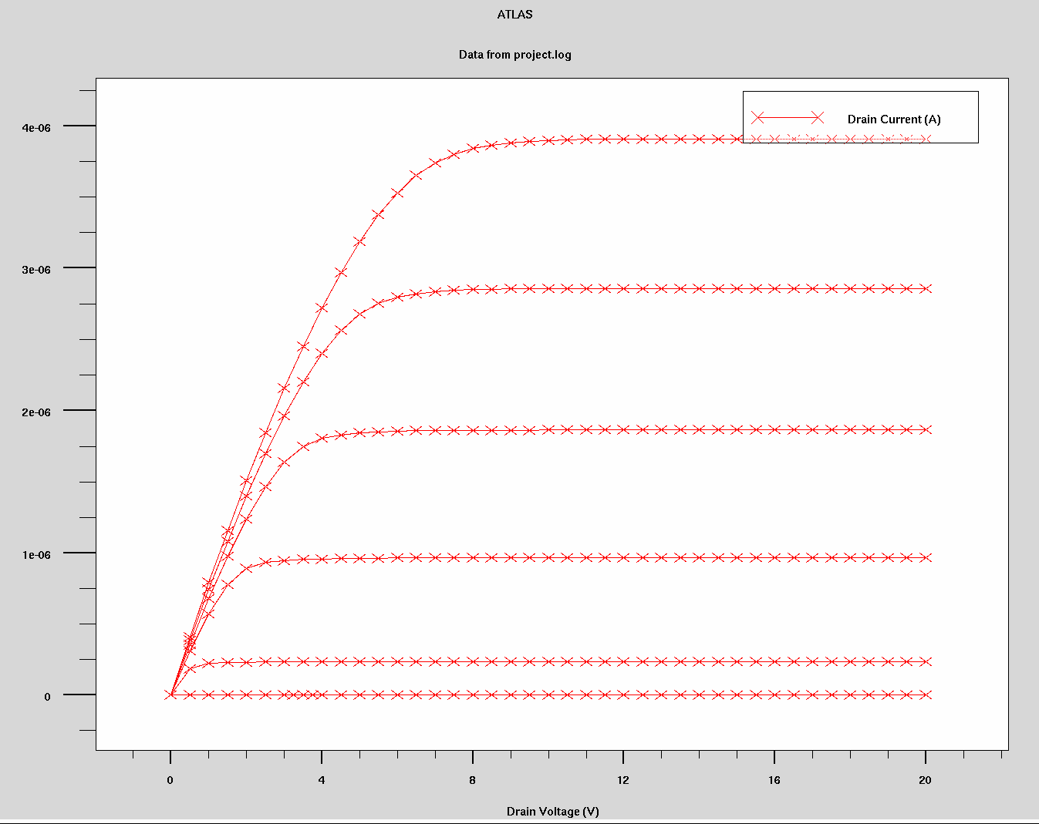
Figure 8: The SUPREM plot of the MOSFET Id vs. VGS
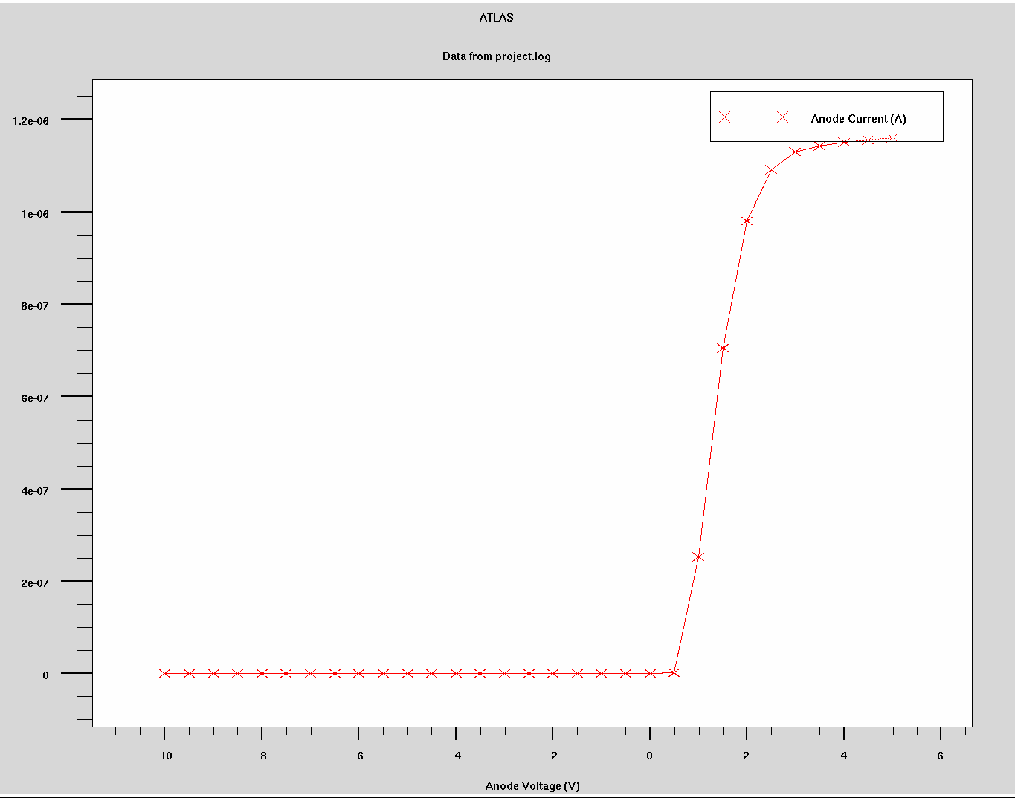
Figure 9: Diode Ia vs. Va SUPREM Plot

